Building Mobile App

Configuration the Mobile App for Controlling Motor Using Buttons

|  |  |
| --- | --- |
| Date | 27 October 2022 |
| Team ID | PNT2022TMID47383 |
| Project Name | Real-Time River Water Quality Monitoring and Control System |

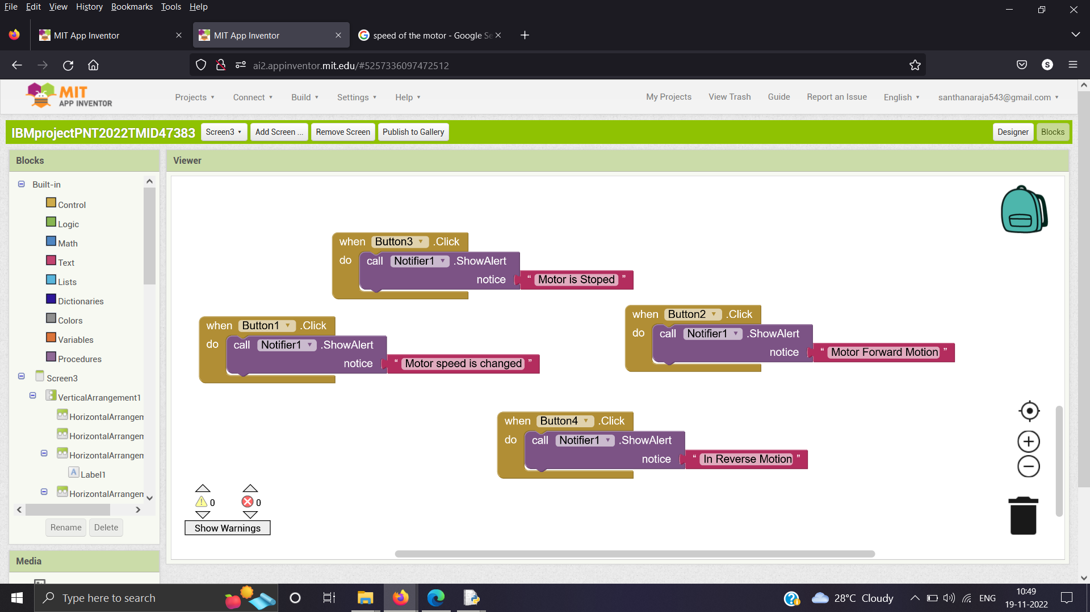

The above this has the motor controls to control the shutter gates and speed of it.

